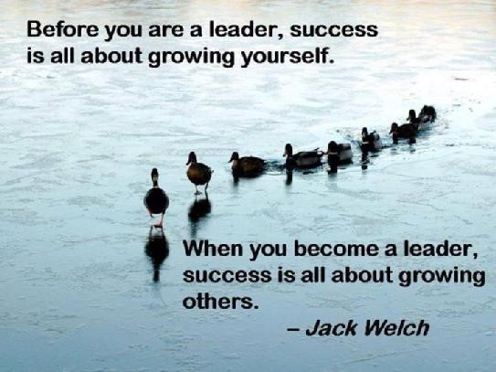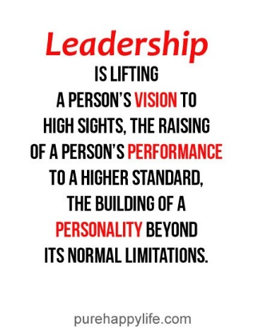**Mary E. Fox**   
**My Philosophy Statement**    
 I believe that leadership is the art of inspiring, motivating, and uplifting oneself and others in order to achieve goals and realize dreams. I believe that we are able to become this type of leader by constantly learning and developing ourselves. I believe that leadership is an art, because it gives one the profound influence to enhance his/her followers—it is the amazing process of transforming an individual, leader or follower, into something far beyond the present. Like a blank canvas turned into a masterpiece, leadership transcends us to be something better than our expectations. I believe a leader is someone who has learned how to use their wisdom, charisma, integrity, self-awareness, and motivation to transform herself (as a leader) as well as her followers to make a positive impact.   
 A leader should use her wisdom of prior knowledge/experiences to help her solve problems. The lessons learned in the past can aid in developing the leader and supporting the followers. This is echoed in the theory of the Skills Approach. Wisdom is also important in problem-solving, critical thinking, and emotional intelligence. It means being able to rely on prior knowledge and to reflect on past experiences in order to cope with problems and various emotions felt today.  
 Leaders should also possess charisma. Charisma means to stand out and persuade the follower to join the mission. This is a powerful attribute to have, and I believe it is important in both motivating people to be a part of the “team” and in inspiring the followers to keep up the work needed in achieving a goal. It means being attractive, likeable, relatable, and infectious through character (Transformational theory).   
 While leaders do have extreme power in certain ways, it is also important that they act with integrity. The leader should be honest, open, and upfront with herself and her followers. I believe that the best leaders must first analyze how they behave before they can ever truly lead another. Integrity also means leading by example, meaning what they say/saying what they mean, keep their word, and inspiring others to do the same. This is crucial in the “Model the Way” element of the Five Practices of Leaders under Transformational leadership. In addition, many elements of the integrity of leaders is discussed under Authentic leadership.   
 Self-awareness is a significant part of leadership in my opinion (Authentic leadership). This includes knowing who you are, how you think, what your “story” is, how you see yourself, and how you govern your actions as a leader. I find this to be so important to leading others because it means knowing why, what, and how you do what you do—it gives both meaning and purpose to your actions as a person and as a leader.   
 Lastly, leaders should be both motivated internally and externally. Leaders should have the ability to inspire themselves to do what is right, complete the task, strive for the great dream, and reach a grand purpose. In doing these things, motivation is then passed on to followers to share in the vision and act with purpose. This is another part of the Five Practices of Leaders (Transformational theory), and I believe it is a fundamental piece to being able to lead another. Motivation pushes us to strive for great things. Motivation encourages us to reach goals we believe are beyond our own limits. We look to motivational leaders when we feel we cannot go on, and we are propelled by them to reach great heights. Adaptive leadership theory uses motivation to help others do “the work.”   
 I personally ascribe myself to a blend of Transformational, Skills Approach, Adaptive, and Authentic leadership theories. I find that elements of each are crucial to understanding how I lead and how I may develop my leadership abilities.

I am highly inspired by leaders of all types, but the leaders who possess the ability to really transform me into something more than I had imagined possible are the ones I truly believe in.

My dad was one of my earliest encounters with what I believe it means to be a leader. He was very wise, and he enjoyed sharing his wisdom. From very early on, he enjoyed telling my sister and I about things he had experienced in his life. He often used this wisdom to solve problems at his workplace. He worked as a computer programmer, so his ability to solve various problems was highly sought after. He constantly thought out ways to resolve issues for his company. He knew from his prior experiences that trial-and-error was a huge part of critical thinking, and he was not the least bit afraid of failure—he knew it was a stepping stone which would point him to the right decision. My dad was also incredibly charismatic. He volunteered at my school functions, and he was always able to attract people to whatever idea he came up with. People flocked to him, believed in him, and really adopted the vision because he was so enthusiastic about the goal. He also taught me what it means to behave with integrity. He lived by his word and truly modeled the way for my sister and I. He kept his promises, treated people with the ultimate respect, and never sought to get ahead by being dishonorable. My dad knew who he was, and he was entirely comfortable and confident of his story. He possessed self-awareness so great that people found inspiration in his story as much as he did. He could motivate people to do anything, and he believed in people so strongly that it was hard for those around him to quit on a goal. His followers at work, at home, and amongst his friends could trust him, rely on him, and found purpose because of him. For me, my dad embodies what it means to be a transformational leader. He had strong values, great ability in motivating, respected his followers, and developed people into transformed beings who he believed could conquer anything.

Another example of the truly profound leaders I have known include Mr. Owens, my high school Humanities teacher. Upon reading about Authentic Leadership, this particular educator immediately came to mind. There is something so real and genuine about him. The students affectionately called him “Owens,” like he was one of our best friends. And Owens, reflecting on various turning points, would entertain us with stories about his life. He knew and trusted his own story so completely that he ended up writing a book (and later narrated YouTube videos through the Self Narrate channel) called “Cool Blue.” He possessed the intrapersonal aspect of Authentic leadership through these stories and his grand conviction to who he is inside. He was unlike any teacher I had, a true original. He confidently addresses each student by name even after years of having graduated and remembering us as individuals. He enjoys the reciprocal nature of his relationship with students, and he instills students with encouragement and knowledge. He possesses the interpersonal characteristic of this theory through his relationship with his students. And lastly, he possesses the developmental part of being an Authentic leader through his stories. He is both able to be self-aware and ethical, while seeing his own life as a process through which he has emerged a powerful influence on those around him.

